ATB 2016 – Riding in storm force winds
The 2016 Around the Bay was a bit of a challenge this year, not just because the weather was forecast to be “gusty”, but because I had taken on the job of organising the accommodation for the ER crew too. That proved to be almost as tough a job as the event, in the end. It’s a bit like herding cats, but we got there and the weekend turned out to be one of the best ER events I have been involved with.
Just remember, if you are going the Adina Apartment Hotel in Northbank (on Flinders Street), its NOT the Adina Apartment Hotel on Flinders Street – that is a different hotel. It seems that the key word is Northbank – a bit of a trap for young players there.
Anyway, on a sunny but not so warm Friday afternoon Chris Prax (Limpet), Jenny (Doc), Ed Sice (Yeah Baby!) me (Victa), Dave Smith (Top Gear) and Matt Day (Manga), had the bikes ready to go for a little leg turner. Ed’s bike was still on its way down to Melbourne by car with Philby and Ange, so Ed hired an old steelie and a helmet so as not to miss out on the ride.
We thought we’d head to St Kilda for spin but got a bit lost on the way and ended up riding down a major highway with no bike lane in heavy Friday afternoon traffic immediately after we left the hotel. It turned out we should have gone right, not left. After a hair raising shuffle between and beside cars, we started heading towards what we thought was St Kilda.
However, it wasn’t that simple and we ended up near Albert Park, resplendent in our ER gear and mounted on thousands of dollars of carbon when a lady on a rusty steel duchess with basket and paniers sailed past us in the bike lane – it was a bit embarrassing really – but we eventually found our way around the Albert Park lake and headed to St Kilda. It had taken so long to get there, we needed beer.
We found a small café with heaters (yes, it was Melbourne and the weather is a bit unpredictable – you may hear that again later) as it started to rain so we settled in for beer and hot chips before heading back to the hotel after the showers had passed, stopping off at the grand prix circuit for a quickish blast around the lake. It is so much fun just letting it all go in a flat out sprint!
My Strava profile looks like a spider which had imbibed a bit too much of what we were having at the café.
Saturday was glorious – we had already decided to go for a spin early so we headed out to ride down the coast towards Sorrento, aiming to turn around at Mentone. It was a bit windier than we had anticipated and ended up being a bit faster than I had hoped for the leg turner the day before a major ride, but it was fun nonetheless.
For anyone who has never ridden a flat course before, the technique is completely different to riding in hills. It is based on finding and sucking someone else’s wheel for as long as they are going at your speed then, if they slow down, you DO NOT PASS – you also slow down and wait for a faster rider to go past and jump straight on to their wheel. Melburnians are past masters at it but us stupid Sydneysiders still have a lot to learn.
We mistakenly passed a group and immediately picked up a couple of dozen riders who burned us then jumped on the next fast group to go by. Rides are based on your ability to maintain an average speed for the entire ride – 30 km/h, 33 km/h, 38 km/h etc. We stopped and messed about so our average was pretty poor at 26 km/h but it was great fun.
We also came across about 70-80 riders who were doing a u-turn at Black Rock, which caused a bit of amusement for us seeing all the cars being held up and a lot of fury for the car drivers nearby. It turned out they were riding in memory of a mate who had been killed at the spot and were just turning back to head home.
The rest of the day was spent looking for food, eating food or drinking beer, or shopping with WAGs and thinking about tactics and the weather. Manga found a couple of little restaurants near our hotel and we ended up at a Taiwanese restaurant for a large dinner, beautifully organised and ordered by Doc.
Did I mention Melbourne’s weather? The forecast was for rain in the afternoon, a bit of wind and cool temps.
Sunday broke early, with a 5.15 departure from the hotel. I was minding my own business when Highlander rang and asked whether I intended to ride and, if so, would I mind making my way downstairs?
Everyone was there – Philby and Ange, Turnip, Highlander, Manga, Yeah Baby!, Doc, UNick and Limpet. We were going to catch Top Gear at the start line as his family was in a different hotel. That could be challenging as there were almost 10,000 riders registered for the ride. However, the ER gear stands out in a sea of blue.
We got to the line with a couple of minutes to spare….and we were off!
It was difficult to stick together with so many riders but I managed to stick with the Hobbits who were setting a reasonable pace. Yeah Baby?, Philby and Ange were behind me somewhere.
We hadn’t found Top Gear at the start but soon passed him standing on the side of the road. He had gone with the very first wave and had pulled over to wait for the Egg and Tomato shirts to flash past. We called out as we went by but, because of the number of riders, he wasn’t quite able to catch us.
The Westgate Bridge descent gave us our first taste of the winds to come – it was a bit breezy but nothing too outrageous. Melburnians trying to squeeze through non-existent gaps between us was more of a hazard. The sun started to show its face to the east with a spectacular reflection off scattered clouds.
With a strong tail wind, the run to Geelong was fast, except for a 10 stop for a flat tyre for Manga and pit stop for us boys. Ange and Philby passed us at this point, waving as they sailed by. No one had seen Top Gear since we passed him near the start on the side of the road. As he is my close friend and riding buddy, I prayed that he was OK. He is a strong rider so he should have caught us by now if he hadn’t had to pull out.
With new tube fitted, we broke into the Hobbits on the 250 km ride and me, Manga and Yeah Baby! on the 210 going our separate ways.
The countryside around that part of Victoria is really boring and flat so I concentrated on staying upright, passing slower groups and generally enjoying the quiet that goes with a tailwind.
Geelong came and went and we filled up with cake, fruit and chocolate at the official rest stop. The Hobbits were just leaving as we arrived. Then on to Queenscliff. The rides divide at this point with the 210 km ride going straight on across the Bellarine peninsula and the 250 km ride turning left, into the wind.
We got a real sense of the wind for the first time on this leg, with a very strong cross wind from back left that kept pushing me out into the middle of the road.
I asked a guy who looked like he was about to die if he was OK. He told me he had never ridden more than 70 kms before, was from Melbourne, and was going to complete the 210 kms. I wished him luck, knowing that from the look in his eyes, he may just about make the ferry, but it was doubtful.
As we rode towards Queenscliff after the junction of the 210 and 250 km rides, we turned into the wind and the group I was in simply fell apart. Manga was two riders ahead of me, powering on, but the smaller riders and two girls almost stopped in their tracks. I got into the drops and put my head down – this is going to hurt.
Soon, Manga and I arrived at the ferry and were ushered straight on, no time to collect valet bags, gels, or spares – shit! All my nutrition was in that bag.
Ed (Yeah Baby!) appeared from nowhere, his face lit up with delight at seeing us. We were loaded on to the ferry and rushed upstairs to get seats near the café. The crossing was a touch bumpy but the room was warm and had toilets!
We got a message from Top Gear to say that he had crossed on the 9.30 ferry and was waiting for us on the other side! How the hell did he do that? He must have passed us at the puncture stop.
Once offloaded, we found Top Gear and headed off for the return leg. The first part of the ride was reasonable, with protection from the wind but as soon as we started turning north, the blast hit. The wind was so strong at points, it was picking up sand from the beach and sand blasting any exposed skin. This part was challenging for me as I had 50 mm deep wheels on my bike and was getting pushed around a lot.
This year’s event saw Mt Martha expunged from the ride because no one in Mexico can ride up hills. Instead, the course was moved to the coast – just what we needed - more gale force winds riding along the cliffs above the beaches. The “shortcut” added about 10 kms to the ride and met up with the main road at Mt Eliza. I have rarely had to ride down a reasonably steep descent pedalling flat out to avoid stopping, but that is what happened on the descent to Frankston. By now, Manga and I were alone. Top Gear and Yeah Baby! had dropped off near the underpass at the start of the beaches “shortcut”
The next 40 kms were just a painful, trudging slog. At points, I was standing on the pedals at full power and managed an average speed of 13 km/h. Then the gusts would just stop and I would fly forwards, only to slammed by another gust that just stopped me again or threatened to blow me off the bike.
At the last stop, with 30 kms to go, Matt and I filled ourselves with Coca Cola and gels from the shop. There was no food, no massages nor many facilities this year, unlike last year, which was a bit disappointing. However, after a decent rest and cold Coke, we set off together into the gales.
That last 30 kms is the longest 30 kms of my riding life. At times I was leaning at 30 degrees into the wind. This leg went on forever – except for the bit where we turned left for a couple of hundred metres and were protected by buildings from the wind – that was fun. Manga commented that it was the first time in more than an hour that we had gone above 20 km/h!!
We eventually arrived back in St Kilda and turned right, away from the beach. Thank God, no more wind! The Spirit of Tasmania was heading out across Port Philip Bay. I remember thinking that they would need a few sick bags on board.
Manga and I crossed the line together in 10h 29m 42s to the cheers of my wife and daughter, and Ed’s wife Ros. Dave (Top Gear) followed about 15 minutes after that to lots of fist pumping and cheers from us and then Ed (Yeah Baby!), whose face was just one massive grin from ear to ear, about 15 mins later!! What a champion – he did virtually no training and got through on sheer determination to finish the ride. He tells me he is signed up already for next year! The official website reckons it was the hardest ATB ever. My legs tends to agree.
To celebrate, we hit the beer tent and put away three jugs of cold ale. Dave’s wife and daughter joined us too. Tall tales were being born in our heads even as we drank from those plastic cups, but that beer never tasted so good.
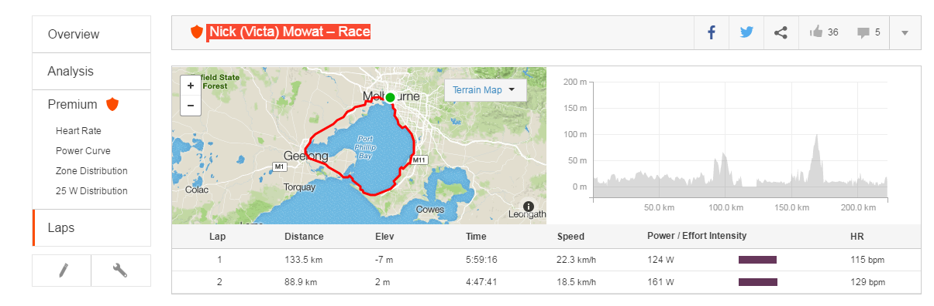
That was one hell of a ride. My altitude profile (before correction) showed that I started at sea level and rode uphill for 222.4 kms – it certainly felt like it. It has now been corrected and is below.
At Queenscliff, I set a lap marker. The details above show how much more work I had to do on the second part of the ride – an extra 37w to go 4km/h slower! My Garmin calorie burn was 11,490 calories for the ride. Strava corrected that to a more realistic 5,111 calories.
Here is my ride, including power details:
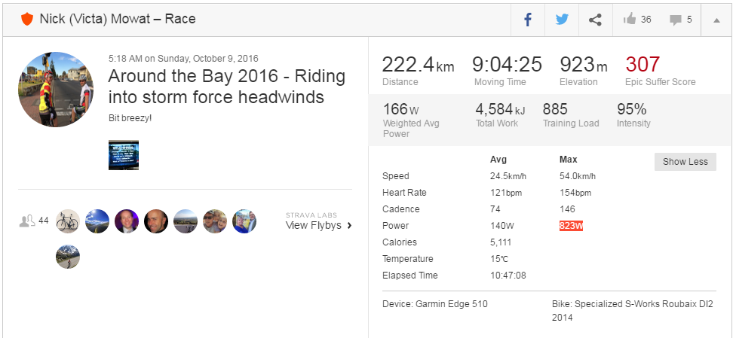
Once Philby and Ange and the Hobbits on the 250 kms ride arrived, having been drenched on an open ferry between Queescliff and Sorrento, we all headed out the Irish Times pub in Little Collins Street with wives, partners, children and Conor’s brother in tow and had a hell of a feeding frenzy, washed down with pints of Kilkenny.
What a cracking weekend. It is on rides like this when you are really tested, that you know what a great bunch of people the ERs are. I want to thank everyone who came, who contributed and who rode, and I also want to thank our partners/wives, who have to listen to nonsense like this which means something to us but is just blah, blah, blah to them. Bring on next year!
Victa

